# Chile – Script Instruction

**URL:** <https://www.bcn.cl/leychile/>

## Initial Setup

1. Open the URL.
2. On the landing page, click “Advanced Search”. You will be redirected to the Advanced Search page.

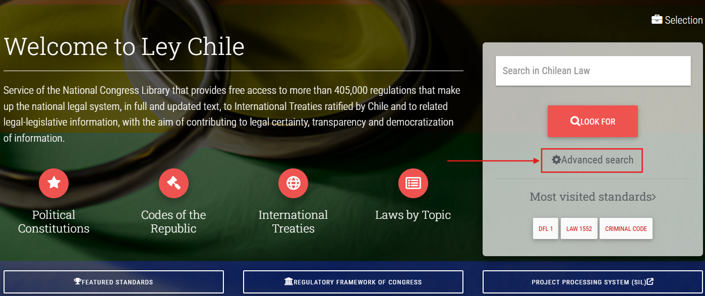

## Advanced Search Setup

1. The keywords must be entered into the “Word or phrase” field with quotation marks. Ensure that the “EXACTLY” option is selected.

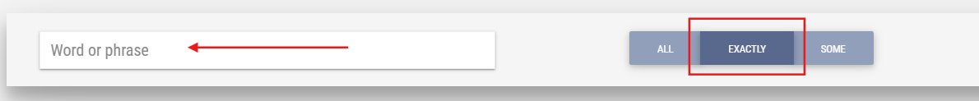

1. The type of regulation is found under “Identification of the Standard”.

**Note:** Only one type can be selected at a time. Please select only “Law” or “Decree” from the dropdown option during keyword searching.

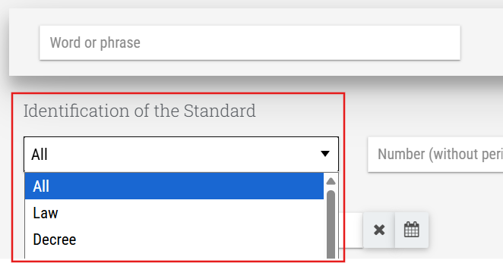

## Extraction of Metadata

1. After setting the filters, enter the Spanish keywords into the “Word or phrase” field with quotation marks, then click the “Look for” button. (*Please refer to the list of keywords file.*)

1. For example, entering “SERVICIO DE BIODIVERSIDAD Y ÁREAS PROTEGIDAS” (Biodiversity and Protected Areas Service) returns [19 results](https://www.bcn.cl/leychile/consulta/listaresultadosavanzada?stringBusqueda=-2%23normal%23on%7C%7C46%23normal%23(%7B%22SERVICIO%20DE%20BIODIVERSIDAD%20Y%20%C3%81REAS%20PROTEGIDAS%22%7D)%23()%7C%7C2%23normal%23XX1%7C%7C117%23normal%23on%7C%7C48%23normal%23on&tipoNormaBA=&npagina=1&itemsporpagina=10&orden=2&tipoviene=1&totalitems=&seleccionado=0&taxonomia=&valor_taxonomia=&o=experta).
2. Click each result entry (the Law/Decree Number in red text) to access the full legislation page.

Then extract the following metadata. We use the [Law 21600 | CREATES THE BIODIVERSITY AND PROTECTED AREAS SERVICE AND THE NATIONAL SYSTEM OF PROTECTED AREAS](https://www.bcn.cl/leychile/navegar?idNorma=1195666) as an example.

**Source Link** – the URL of the legislation page.

**Original Title** – labeled in red, combine the legal citation and the legislation name, separated by a space, to form the Original Title.

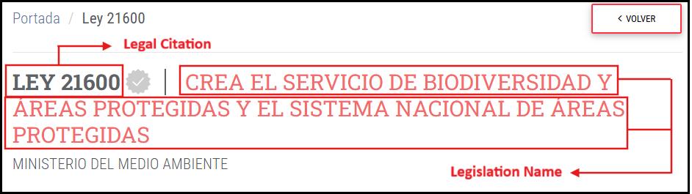

In this case, the original title will read as:

English: *LAW 21600 CREATES THE BIODIVERSITY AND PROTECTED AREAS SERVICE AND THE NATIONAL SYSTEM OF PROTECTED AREAS*

Spanish: *LEY 21600 CREA EL SERVICIO DE BIODIVERSIDAD Y ÁREAS PROTEGIDAS Y EL SISTEMA NACIONAL DE ÁREAS PROTEGIDAS*

**Type of Regulation** – inferred from the title, labeled in green:

* Ley (Law)

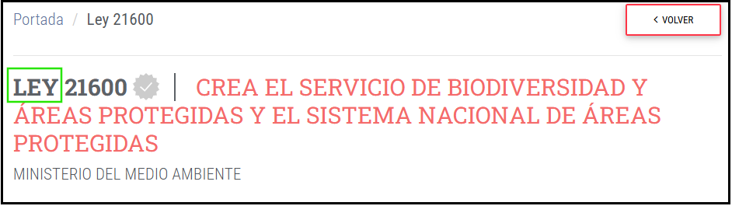

* Decreto (Decree)

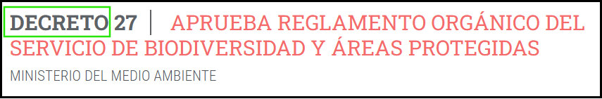

**Date of Adoption** – capture the Promulgación (Promulgation) as the Date of Adoption, labeled in blue. The date format on the platform is in DD-MMM-YYYY. You should change this to YYYY-MM-DD in the output.

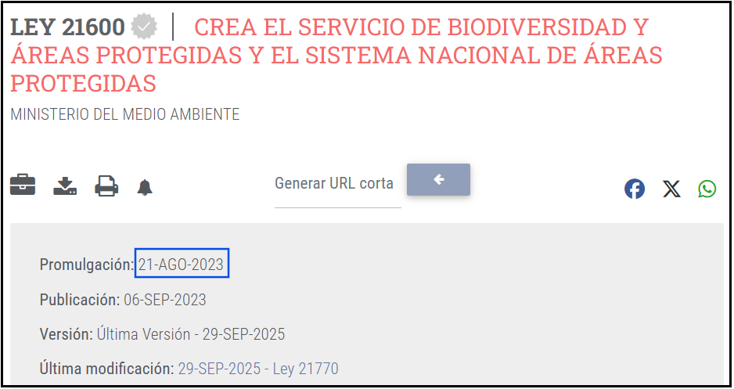

**Entry into Force Date** – capture the Publicación as the entry into force date, labeled in purple. The date format on the platform is in DD-MMM-YYYY. You should change this to YYYY-MM-DD in the output.

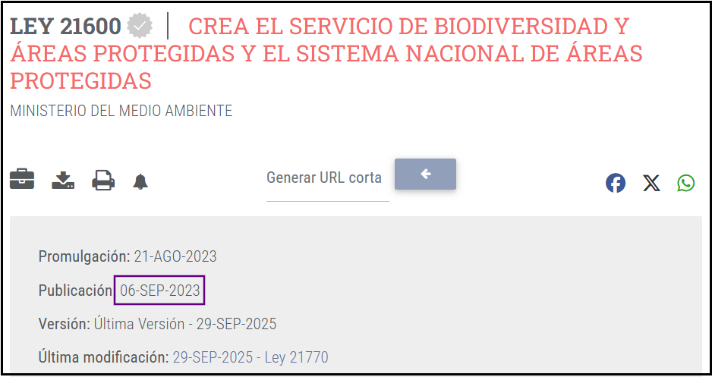

## Important Reminders

1. Duplicate titles and/or source links should be removed and retain one copy of each duplicate.
2. Follow this date format for consistency – YYYY-MM-DD.
3. Please translate the type of regulation column into English:

* Ley → Law
* Decreto → Decree

1. Add one column beside the Original Title and translate the titles into English.
2. Please exclude any legislations containing the following Portuguese terms in the title:

* apropiación (appropriation)
* presupuesto (budget)
* revocar (repealed)
* revocar (revoked)
* aeropuerto (airport)
* aerolínea (airline)
* designación (appointment)
* designado (appointed)
* paciente (patient)
* coronavirus / COVID-19

For any queries, issues, or clarifications regarding these instructions, kindly post them promptly on our Teams channel so we can provide a timely response or action as needed.

[ESG KLI Project | ESG KLI Project | Microsoft Teams](https://teams.microsoft.com/l/channel/19%3A2cb71aBrx0vDiOIeb2XNrxxCN2EoVFDjq_GOAxRevDY1%40thread.tacv2/ESG%20KLI%20Project?groupId=6f8eb5d6-d2c9-4fe4-a2b2-16b14d6fcc9a&tenantId=be92c534-7b60-4630-bc01-ec5122548d47)